12306.py:

import base64  
import requests  
import re  
import config  
  
def get_point(index):  
  
 index = index.split(',')  
 loc = {  
 '1': '43,45',  
 '2': '106,45',  
 '3': '167,45',  
 '4': '259,45',  
 '5': '42,120',  
 '6': '106,120',  
 '7': '167,120',  
 '8': '259,120',  
 }  
 answer = []  
 for t in index:  
 answer.append(loc[t])  
 return ','.join(answer)  
# 首先做好伪装,伪装成浏览器  
# 实例化一个session  
session = requests.Session() # 自动的处理cookie  
headers = {  
 'User-Agent': 'Mozilla/5.0 (Linux; Android 6.0; Nexus 5 Build/MRA58N) AppleWebKit/537.36 (KHTML, like Gecko) Chrome/70.0.3538.77 Mobile Safari/537.36'  
}  
# 伪装成浏览器  
session.headers.update(headers)  
# 访问登陆界面  
cookie_url = 'https://kyfw.12306.cn/otn/login.html/conf'  
session.get(cookie_url)  
# 下载验证码  
response = session.get('https://kyfw.12306.cn/passport/captcha/captcha-image64?login_site=E&module=login&rand=sjrand&1541760606034&callback=jQuery19106311375523623572_1541759333476&_=1541759333479')  
img_base64 = re.findall(r'"image":"(.*?)"', response.text)[0]  
img_byte = base64.b64decode(img_base64)  
with open('test.jpg', 'wb') as f:  
 f.write(img_byte)  
  
check_captcha = 'https://kyfw.12306.cn/passport/captcha/captcha-check?callback=jQuery19106311375523623572_1541759333476&rand=sjrand&login_site=E&_=1541759333484'  
answer = get_point(input('请输入正确的序号:'))  
response = session.get(check_captcha, params={'answer': answer})  
code = re.findall(r'"result_code":"(.*?)"', response.text)[0]  
if code == '4':  
 print("验证码验证成功")  
 # 验证用户名与密码  
 login_url = 'https://kyfw.12306.cn/passport/web/login'  
 Form_Data = {  
 'username': config.username,  
 'password': config.password,  
 'appid': 'otn',  
 'answer': answer  
 }  
 response = session.post(login_url, data=Form_Data)  
 res = response.json()  
 if res['result_code'] == 0:  
 print('用户名密码验证正确')  
 uamtk_url = 'https://kyfw.12306.cn/passport/web/auth/uamtk'  
 response = session.post(uamtk_url, data={'appid': 'otn'})  
 res = response.json()  
 if res['result_code'] == 0:  
 print('获取token成功')  
 check_token_url = 'https://kyfw.12306.cn/otn/uamauthclient'  
 response = session.post(check_token_url, data={'tk': res['newapptk']})  
 res = response.json()  
 if res['result_code'] == 0:  
 print('验证token通过')  
 print('登陆成功')  
 else:  
 print('用户名或密码错误')  
else:  
 print('验证码错误')

若想简单查询：

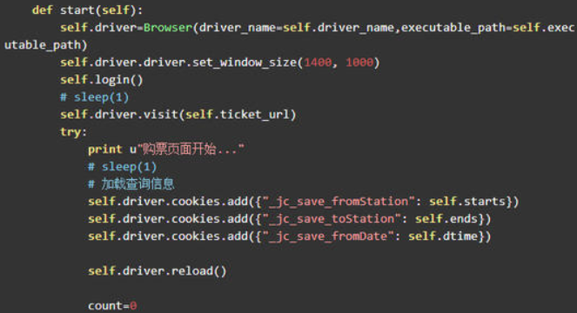

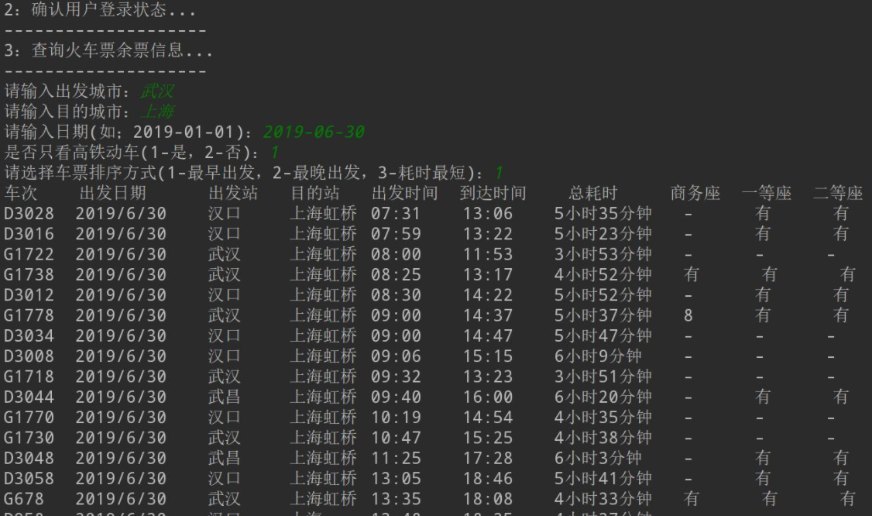

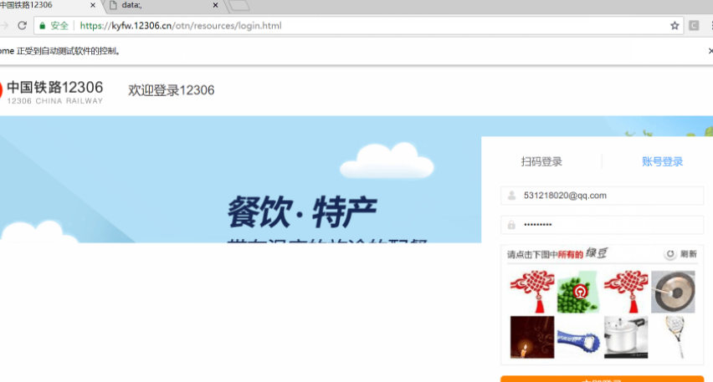

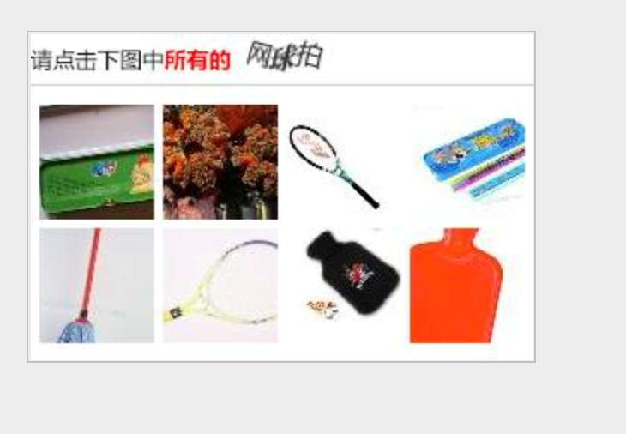

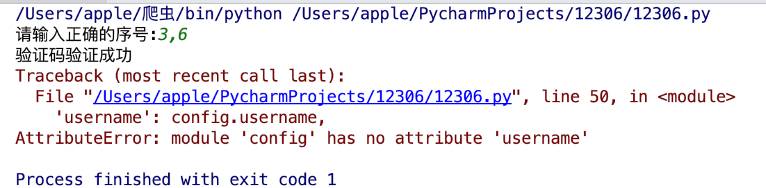

详情地址：

Github: https://github.com/luckyyours/3